## Getting Up and Running with the Power BI Service

**Setup Time**: 60 minutes

**Lab Folder**: C:\Student\Modules\01_GettingStarted\Lab

**Overview**: This lab covers how to get up and running with Power BI by creating a new Office 365 tenant with trial subscriptions to Office 365 and Power BI Pro. The act of creating and configuring this new Office 365 tenant will yield an isolated testing and development environment for working on projects with the Power BI service and using Microsoft’s latest self-service BI tools such as Power BI Desktop and Microsoft Excel 2016. One valuable aspect of creating a new and isolated Office 365 tenant is that you will have tenant-level administrative permissions allowing you to configure the tenant with multiple user accounts for testing your Power BI projects in isolation from any existing Office 365 tenancy.

### Exercise 1: Create a new Office 365 Trial Tenant

In this exercise, you will create a new Office 365 tenant which allows you to create up to 25 user accounts with Enterprise E5 trial licenses. Note that the Enterprise E5 trial license provides the benefits of the Power BI Pro license. Being able to create multiple Office 365 user accounts in your Power BI testing environment will be important so that you can test the effects of sharing Power BI dashboards between users.

1. Navigate to the following URL:

<https://go.microsoft.com/fwlink/p/?LinkID=698279&culture=en-US&country=US>

1. Fill out the form with your personal information and click **Next**.

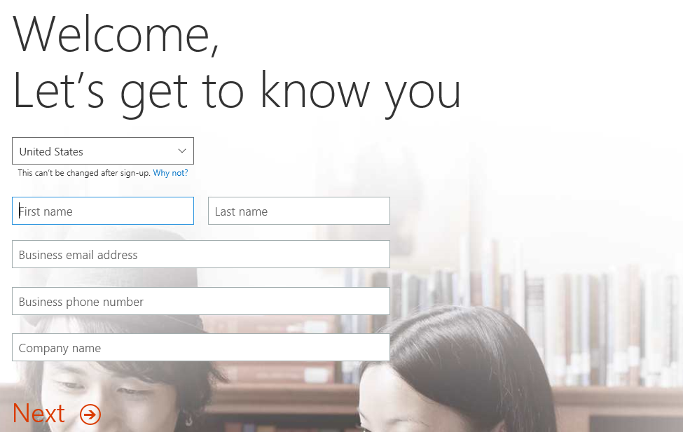

The information you provide here will be used throughout your tenant so if you do not wish to use your actual company name then provide humorous and fictitious company name. The name you use for company name will turn out to be the name of the trial Office 365 tenant that you are creating.

1. On the next page, you are prompted to provide a user ID, company name and password.

Note that the company name you enter on this page will be used to create the domain name for your new Office 365 trial tenant. For example, if you were to enter a company name of **CptPowerBiTenant**, it would result in the creation of a new Office 365 tenant within a domain of **CptPowerBiTenant.onMicrosoft.com**. The user name you enter will be used to create the first user account which will be given administrative rights within the trial tenant. If you enter a user name of **Student**, then the email address as well as user principal name for this account will be **Student@CptPowerBiTenant.onMicrosoft.com**.

1. Enter a user name and a company name for your new Office 365 trial tenant. For the company name, you may wish to simply use your first and/or last name with a number which you can increment each time you have to create a new trial account (e.g. EricClapton1.onmicrosoft.com).

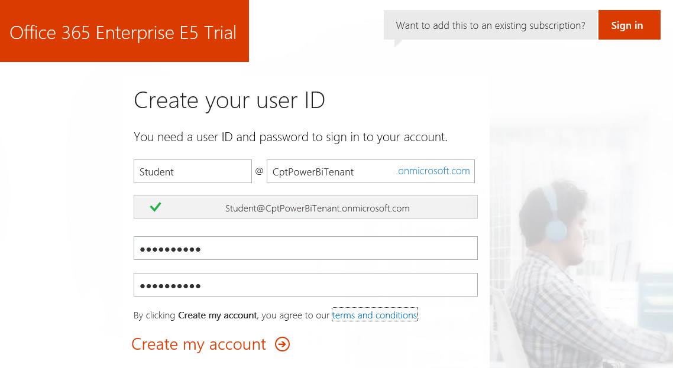

Don’t use your actual company name as that may cause some conflict when your company decides to create their own official tenant. Throughout the remainder of this guide you will see a company domain name of **CptPowerBiTenant** which you should replace with the value specified for your company name.

1. Click **Next** to continue to step 3.
2. Complete the validation form in step 3 by proving you are not a robot.
   1. Select the **Text me** option and provide the number of your mobile phone.
   2. When you go through this process, a Microsoft service will send you a text message that contains an access code.
   3. You retrieve the access code form your mobile device and use it to complete the validation process.



1. Once you have completed the validation process, click the **You’re ready to go…** link to navigate to the portal welcome page for your new Office 365 trial tenant. Note that you should already be logged on using the user account that was created during the sign up process.

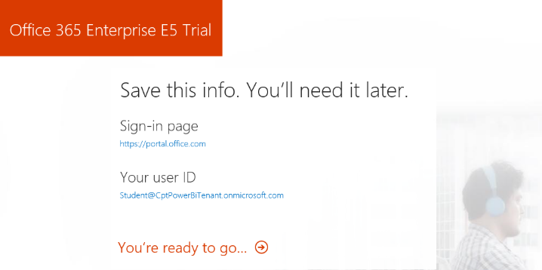

At this point, you have already created your new Office 365 tenant which can support creating up to 25 user accounts with Office 365 Enterprise E5 trial licenses. Note that some Office 365 services within your new Office 365 tenant such as the Office 365 admin center can be accessed immediately. Other services within your Office 365 tenant such as SharePoint Online are not ready immediately and will take some time to provision.

1. At this point, you should be located on the portal welcome page of Office 365. You will notice that this page shows the progress of the Office 365 environment in setting up each of the individual services that make up your new Office 365 tenant. Click the **Admin** tile to proceed to the Office **365 admin center**.

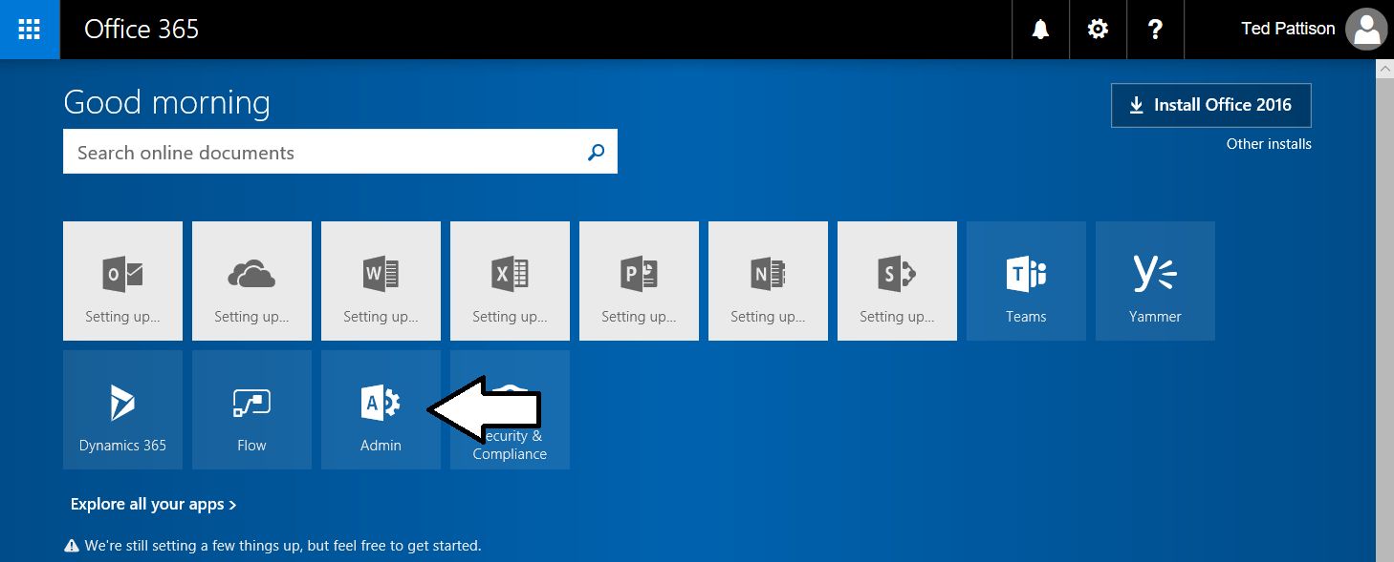

1. If you are presented with the Office 365 admin center welcome dialog, close it by clicking the **X** menu in the upper right corner.

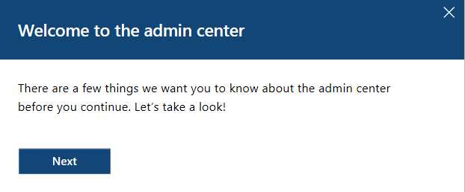

1. Verify that you are able to access the home page of the **Office 365 admin** **center**.
   1. The following screenshot shows the Office 365 Admin home page.

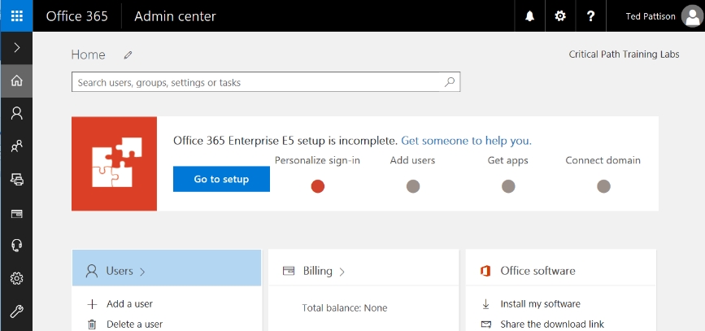

* 1. Locate the top **Menu** button for the left navigation menu. It’s the second button from the top with the arrow icon which sits just beneath the Office 365 App Launcher menu button.

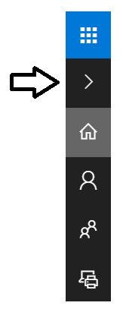

* 1. Click the top **Menu** button several times and see how it toggles the left navigation between a collapsed and expanded mode.

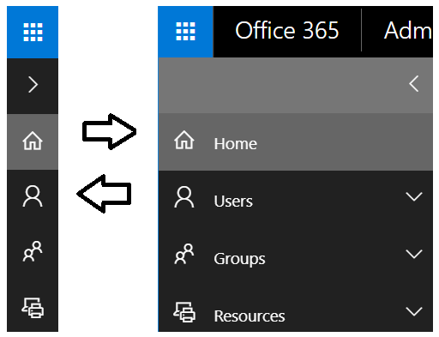

If you are interested in getting more familiar with the **Office 365 admin center**, take a minute to explore the administrative pages behind the left navigation menu in the Office 365 admin center.

### Exercise 2: Add a Secondary User Account for Testing Purposes

In this exercise, you will configure your new Office 365 tenant by creating a secondary user account that you will need later when you begin experimenting with the Power BI dashboard sharing process.

1. Make sure you in the browse at the home page of the Office 365 admin center.
2. Inspect the set of Active Users in the current tenancy.
   1. In the left navigation menu, expand the **Users** node and click **Active Users** to navigate to the **Active Users** page.

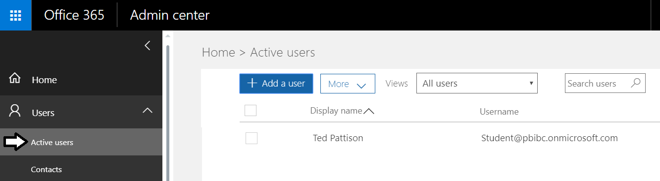

* 1. Once the **Active Users** page is displayed, you should be able to verify that the user account you are currently logged on as is the only user account that exists in the current tenancy. Remember that this account has been set up as a Global Administrator to the tenant because it is the account that was used when creating the tenant.

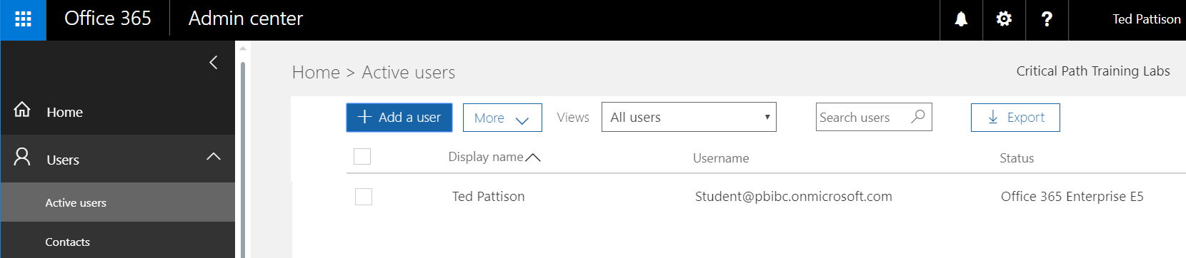

1. Create a new user account.
   1. On the **Active Users** page, click the button **Add a user** button to create a new user account

. 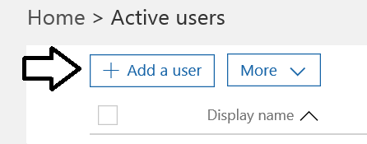

* 1. Fill in the **Create new user account** form with information for a new user account. When creating this account, you can use any name you would like. These lab instructions will demonstrate this by creating a user account for a person named **James Bond** with a user name and email of **JamesB@CptPowerBiTenant.onmicrosoft.com**.

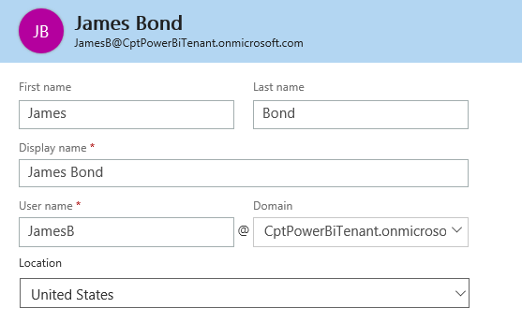

* 1. Expand **Password** section under **Contact Information** section.
     1. Select the option for **Let me create the password**.
     2. Enter a password of **pass@word1** into the textboxes labeled **Password** and **Retype** **Password**.
     3. Uncheck the checkbox for the option labeled **Make this user change their password when they first sign in**.

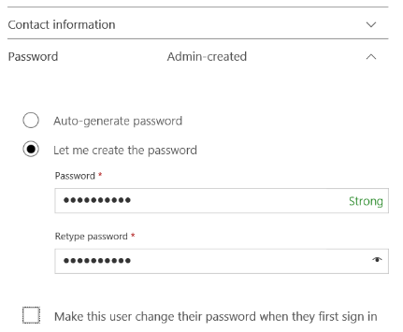

* 1. Expand the roles section. You do not need to change anything in this section, although you should note that this new user account will be created as a standard user account without any administrator access or privileges.

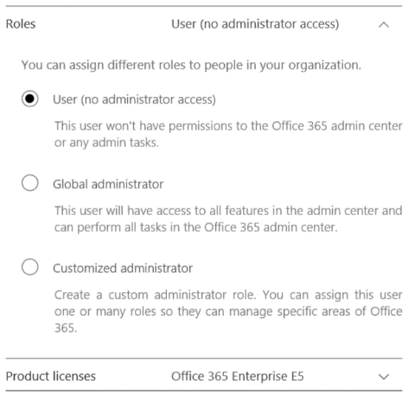

Note that the new account has been automatically assigned trial license for **Office 365 Enterprise E5** plan. That means you do not need to do anything further to enabled support for Power BI. Having the for **Office 365 Enterprise E5** license provides the same level access as a **Power BI Pro** license.

* 1. Click the Save button at the bottom of the new user form to create the new user account.

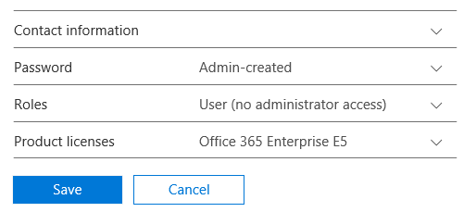

* 1. When you see the **User was added** message, click **Send email and close** to dismiss the **Add new user** task pane.
  2. Verify that the new user account has been created and is displayed along with your primary user account.

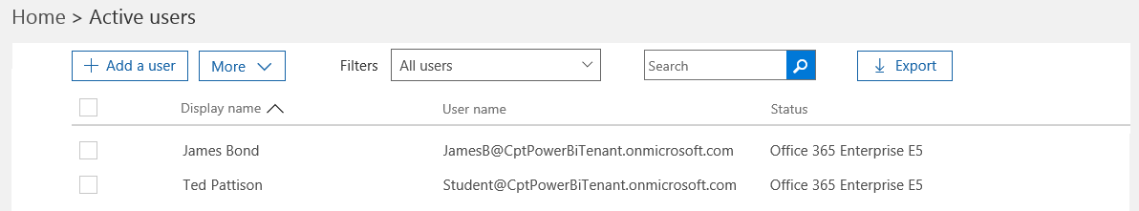

### Exercise 3: Use the Power BI Service to Import a New Dataset

Now, after all that busy work, you are finally ready to begin working with Power BI. In this exercise you will begin by importing data from an Excel workbook to create a new Power BI dataset. In the exercise steps that follow, you will create a report and a dashboard.

1. Use Microsoft Excel to inspect the Excel workbook named **WingtipSalesData.xlsx**. Later in this exercise you will import the data from this Excel worksheet into Power BI to create a new dataset.
   1. Ensure you have downloaded the **Student.zip** file associated with this training course and extracted the contents of this zip archive into a local direct at **C:\Student**.
   2. Locate the sample Excel workbook file at the following path.

C:\Student\Data\WingtipSalesData.xlsx

* 1. Open this worksheet with Microsoft Excel and examine the worksheet and the table inside.

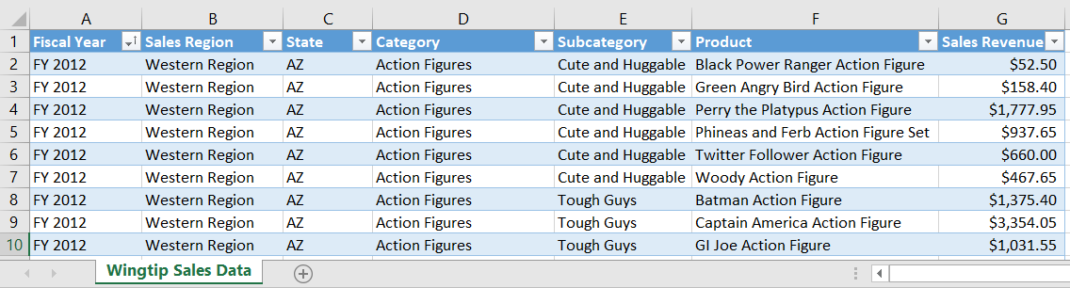

* 1. Once you have inspected the data, close Microsoft Excel without saving any changes to **WingtipSalesData.xlsx**.

1. In the browser, navigate to the Power BI service at <https://app.powerbi.com>.

What usually happens when you navigate to the Power BI Service is that you are shown a view with the dashboards, reports and datasets in your personal workspace. However, your personal workspace is initially empty so it doesn’t contain any dashboards, reports or datasets yet. Therefore, the Power BI service display a special welcome page that allows you to get started by linking to or importing data.

1. At this point, you should be at the Welcome to Power BI page as seen in the following screenshot.

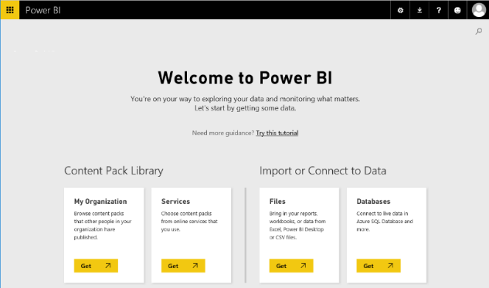

1. Import data from an Excel workbook file.
   1. Click in the **Get** button in the **Files** tile under the **Import or Connect to Data** section header.

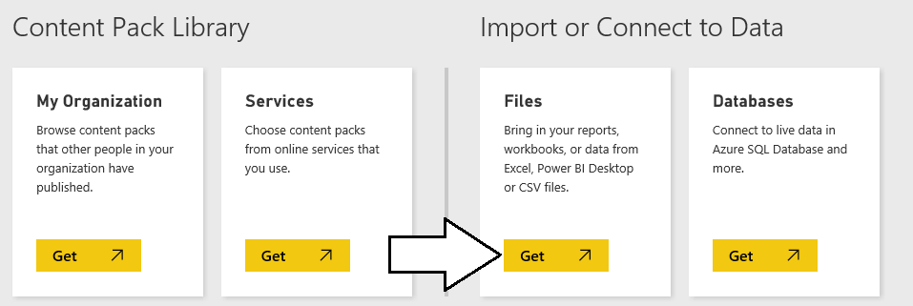

* 1. On the next page you should see several tiles which indicate your choices for the location of the file you would like to connect to or import. Click on the tile with the caption **OneDrive – Business** so you can import data from the Excel workbook you uploaded to your OneDrive site in a previous exercise.

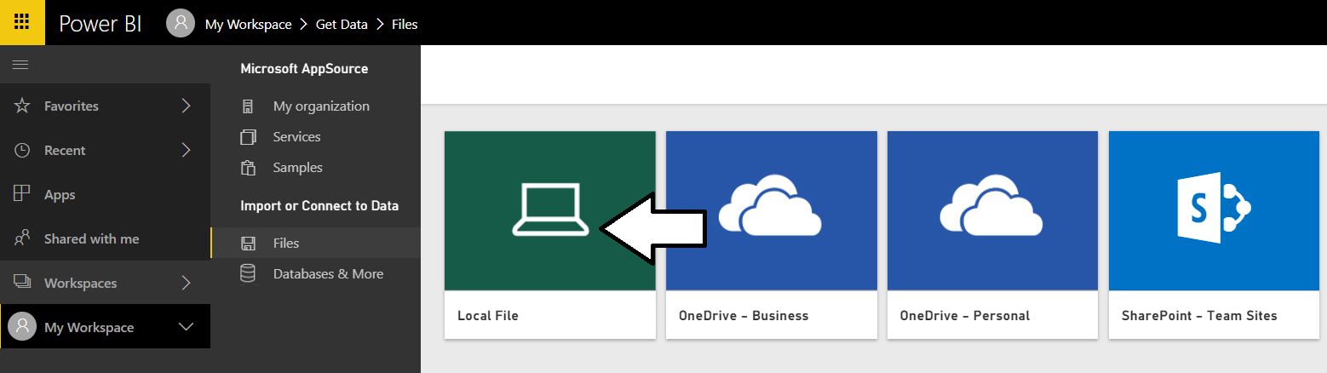

* 1. In the File Open dialog, select the Excel workbook named **WingtipSalesData.xlsx** at the following path.

C:\Student\Data\WingtipSalesData.xlsx

* 1. Once you have selected the workbook file named **WingtipSalesData.xlsx** in the open dialog, click the **Open** button to begin the process of importing the data to create a new dataset.

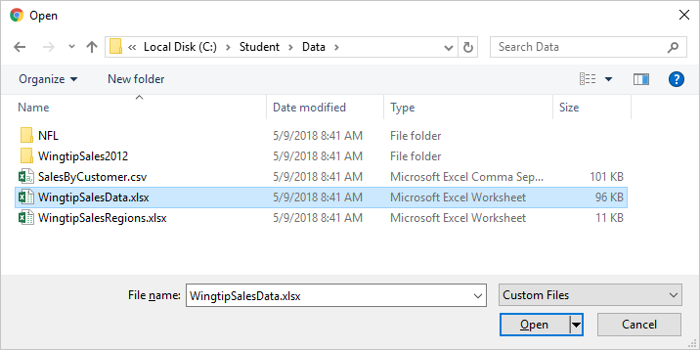

* 1. After clicking the **Open** button in the previous step, you are taken to a page which prompts you to **Choose how to connect to your Excel workbook**. Click the **Import** button on the bottom left-hand side of the page to import data from the Excel workbook into the Power BI service to create a new dataset.

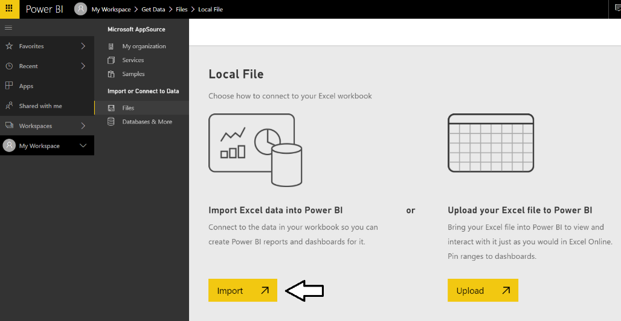

* 1. After the import process has completed, the Power BI service will display a dashboard that was created during the import of the file **WingtipSalesData.xlsx**.

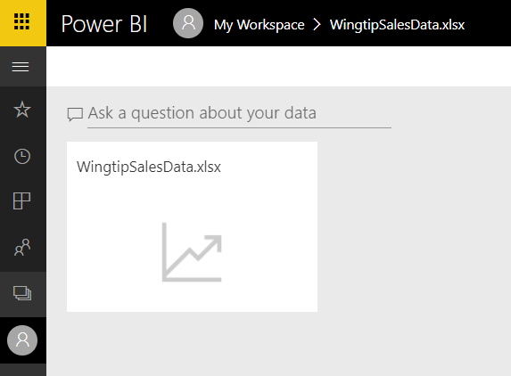

1. Expand the **My Workspace** menu at the bottom of the left navigation menu.
   1. Make sure left navigation is in an expanded state.

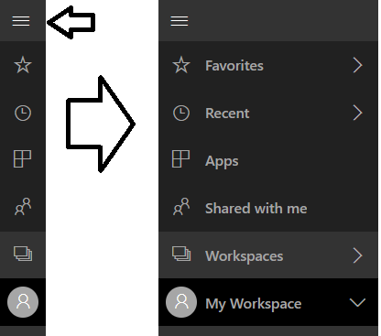

* 1. Click the **My Workspace** drop down menu at the bottom of the left navigation menu to see the workspace contents.

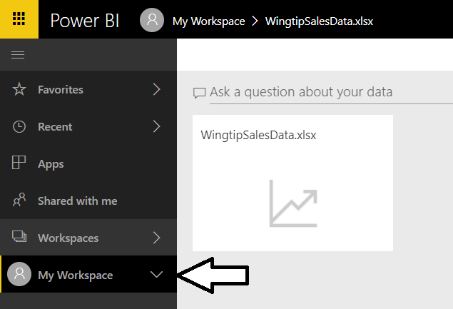

* 1. You should see there is a dashboard named **WingtipSalesData.xlsx** and a dataset named **WingtipSalesData**.

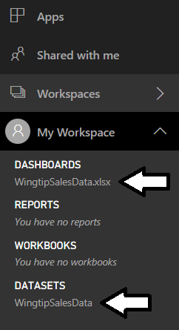

Note that when importing data from an Excel workbook that the Power BI service creates both a new dataset and a new dashboard. However, you might want just the dataset but not the dashboard. You should delete the dashboard if you do not plan to use it.

1. Delete the dashboard named **WingtipSalesData.xslx**.
   1. Expand the ellipse menu to the right of the **WingtipSalesData.xlsx** dashboard and selecting the **REMOVE** command.

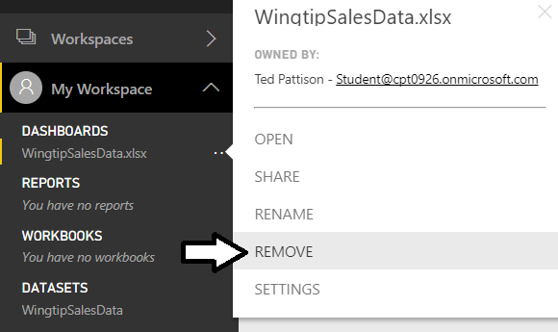

* 1. When prompted, confirm you want to delete this dashboard.

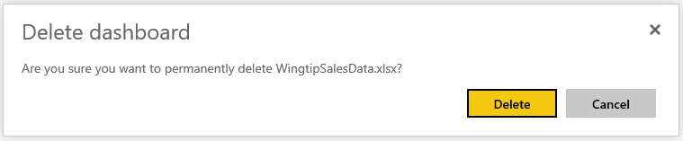

* 1. Your personal workspace now contains the **WingtipSalesData** dataset but there should not be any dashboards or reports.

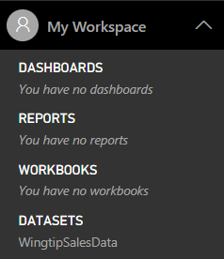

1. Expand the ellipse flyout menu (**…**) to the right of the **WingtipSalesData** dataset link just to see what menu commands are available from you to run on the new dataset you have just created.

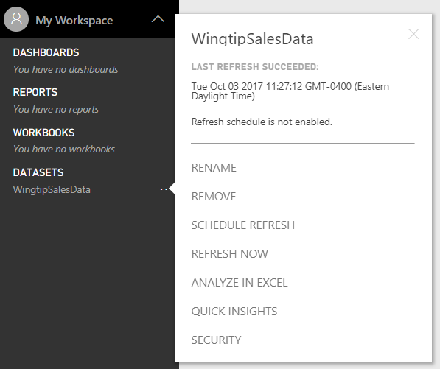

There is no need at this time to execute any of the commands in the dataset flyout menu. You should just observe the commands that you can execute on a dataset that’s been created by importing data from an excel workbook. You can see the menu commands include **RENAME**, **REMOVE**, **SCHEDULE REFRESH**, **REFRESH NOW**, **ANALYZE IN EXCEL**, **QUICK INSIGHTS** and **SECURITY**

### Exercise 4: Create a New Power BI Report with Multiple Pages

Now that you have created a dataset, the next setup step involves creating a new report with two pages of visualizations.

1. Create a new report using the **WingtipSalesData** dataset.
   1. Click the **My Workspace** menu link in the left navigation to display the summary page for your personal workspace. After you do this, your screen should match the following screenshot.

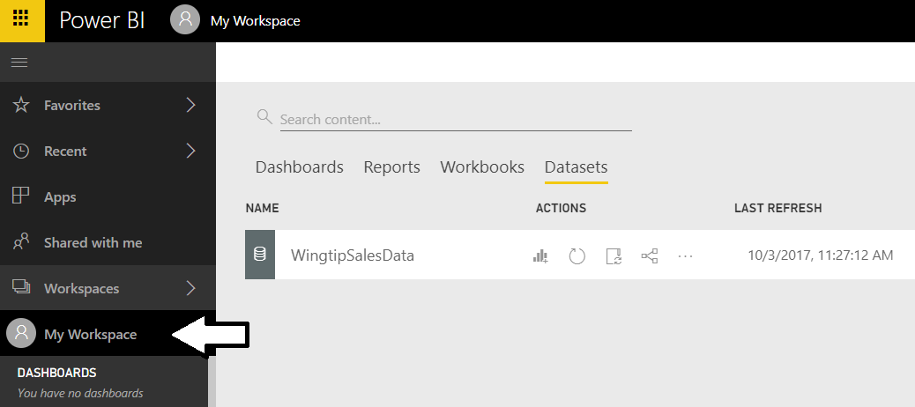

* 1. Locate the dataset named **WingtipSalesData** and click the **Create Report** button to the right.

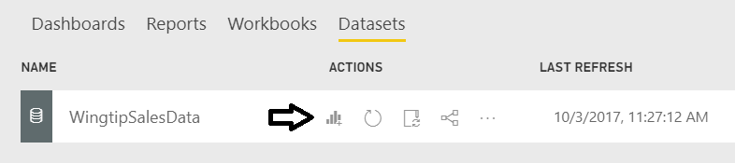

* 1. You should now see a new report in edit view which displays the **Fields** list for the dataset on the right-hand side of the page.

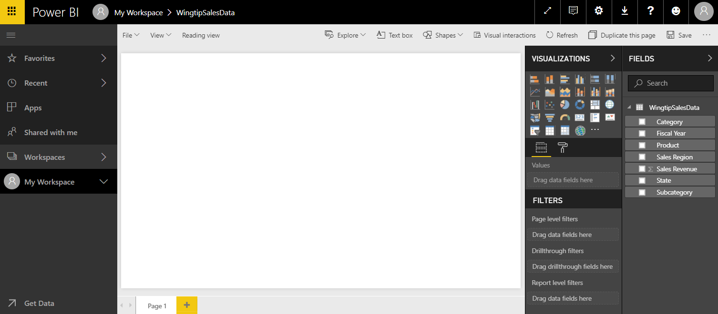

1. Add a new visual to the report to create a line chart.
   1. In the **Fields** list on the right-hand side of the page, click the checkbox beside **Fiscal Year** and then select the checkbox beside ﻿**Sales Revenue**.

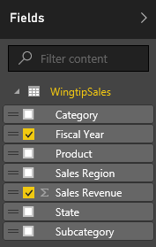

* 1. This should create a table visual in the new report as shown in the following screenshot.

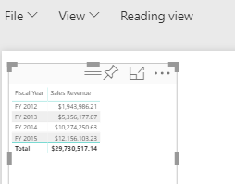

* 1. ﻿Change the visual type from a table to a line chart by clicking the **Line chart** button in the **Visualizations** list.

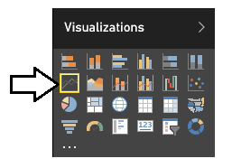

* 1. At this point, you should see that the visual on the report now displays a line chart.

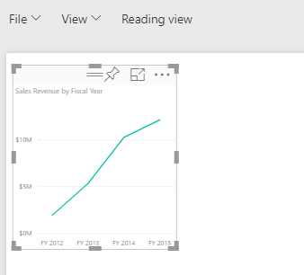

1. Next, you will add a new dimension to your visual to show how sales revenue is distributed across product categories. First, make sure the visual with the line chart is selected and then drag-and-drop the **Category** field from the **Fields** list into the **Legend** well in the **Visualizations** pane as shown in the following screenshot.

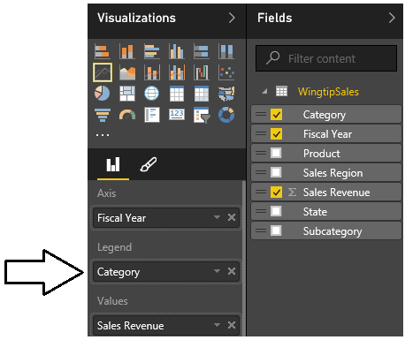

1. At this point, your visual should match the line chart shown in the following screenshot. However, the visual is not yet wide enough to display correctly.

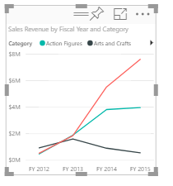

1. Select the handle at the bottom-right corner of the visualization and resize it so it takes up the width of the current report page.

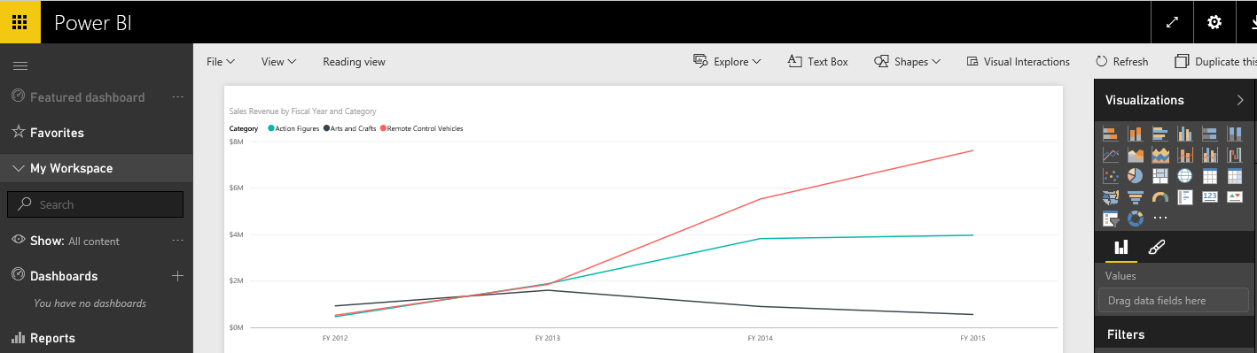

1. Reposition the Line chart’s legend.
   1. Make sure the visual with the Line chart is selected.
   2. In the **Visualizations** pane, click the pen icon to activate the **Format** properties pane.
   3. In the **Legend** section, locate the **Position** property and update it to **Right**.
   4. The legend should now be displayed in the upper right corner of the line chart visual.

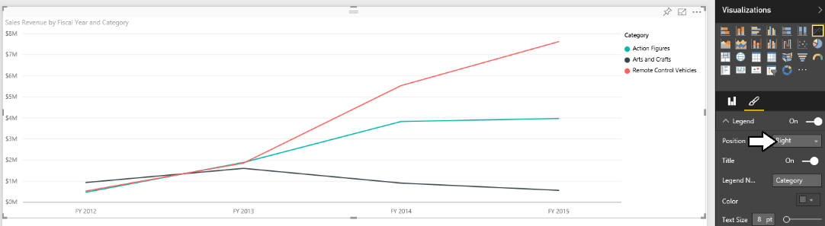

1. Add a second visualization to the current report page.
   1. Begin by clicking the white space under the line chart visualization so that the visualization is no longer selected.
   2. Return to the **Fields** list.
   3. Select the checkbox beside the **Category** field.
   4. Select the checkbox beside the **Sales Revenue** field.

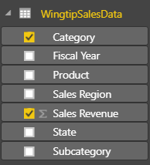

* 1. You should see that a new table visual has been created like the table visual shown in the following screenshot.

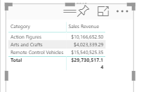

* 1. Change the type of visualization from table to matrix by clicking the **Matrix** button in the **Visualizations** list.

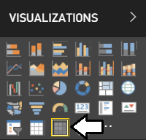

* 1. If you examine the **Fields** pane under the **Visualizations** list, you should see that the **Rows** well contains the **Category** field while the **Values** well contains the **Sales Revenue** field.

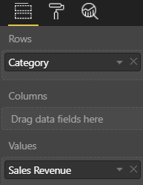

* 1. At this point your matrix visual should look like the following screenshot.

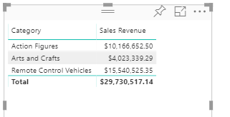

* 1. Drag and drop the **Subcategory** field from the **Fields** list into the **Rows** well below the **Category** field.

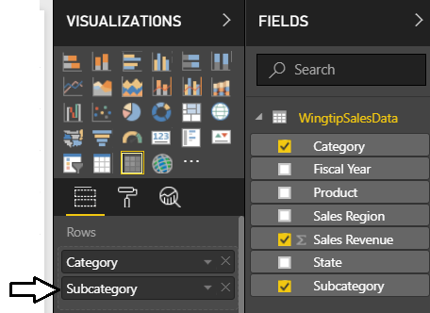

Once you have two or more fields to the **Rows** well of a matrix visual, a new set of button appear at the top of the visual which makes it possible to expand the levels of rows shown.

* 1. Click on the **Expand All One Level** button so the matrix shows subcategories in addition to categories.

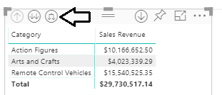

* 1. The matrix in your report should now appear like the matrix shown in the following screenshot.

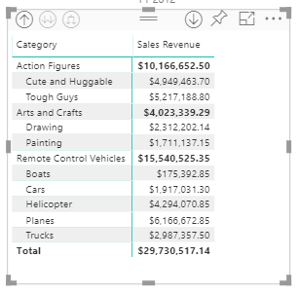

* 1. Inside the matrix, click on the **Sales Revenue** column header to resort the data in the matrix so that the product categories and subcategories with the highest amounts of sales revenue are sorted to the top of the matrix.

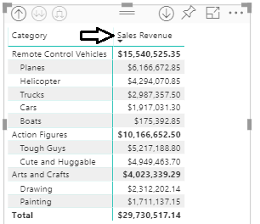

* 1. Increate the font size of the matrix visual by locating the **Text Size** property in the **Grid** section of the **Format** properties pane and setting the **Text Size** property value to **10pt**.

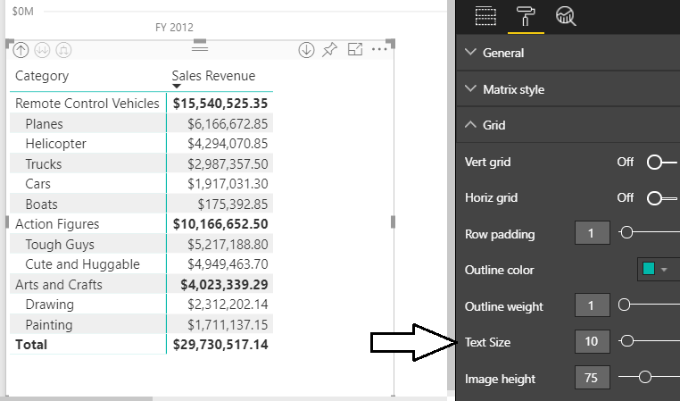

1. Add a third visual to the current report page.
   1. Click the white space on the report page outside of the two existing visuals so that neither visual is selected.
   2. Return to the **Fields** list and select the checkbox beside the **Sales Region** field.
   3. Select the checkbox beside the **Sales Revenue** field.
   4. After creating the new visual, change the visualization type to a to a **Clustered bar chart** using the **Visualizations** list.

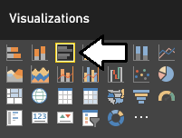

* 1. Using the mouse, reposition the new visual so it takes up the bottom right corner of the page.

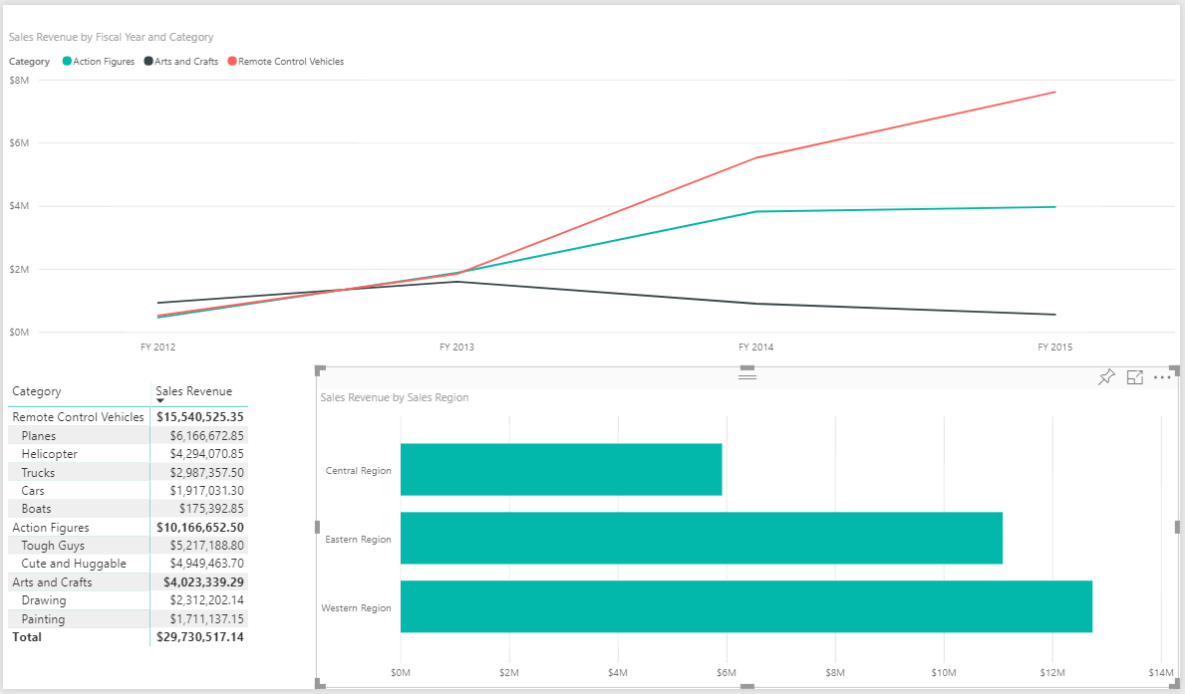

Next, you will add a legend to the Clustered bar chart to visualize how revenue breaks down across product categories.

* 1. Make sure the Clustered bar chart visual is selected.
  2. Click on the chart icon in the **Visualizations** task pane so you can edit the **Field** properties of the new **Clustered bar chart**.
  3. Drag the **Category** field from the **Fields** list into the **Legend** well in the **Field** properties pane.

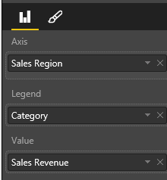

* 1. You should not see revenue for each sales region is further broken out by product category.

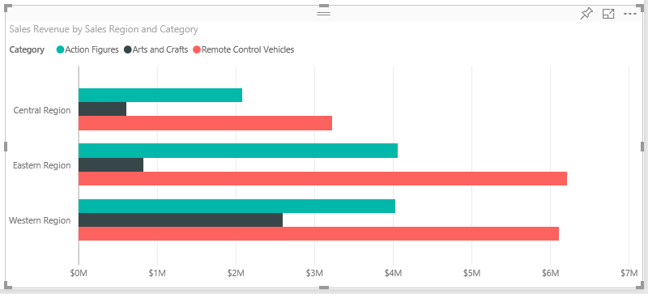

* 1. Modify the position of the legend for the Clustered bar chart to the right.

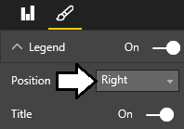

* 1. Your Clustered bar chart should now look like the one in the following screenshot.

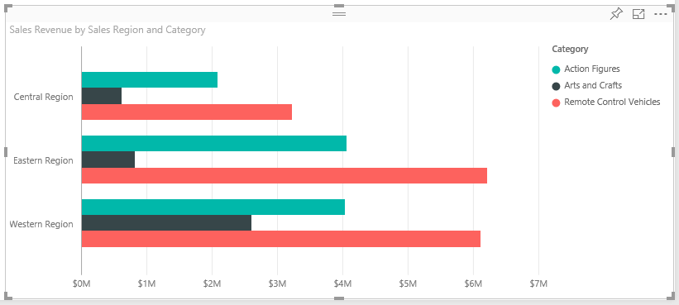

If you have time, you might explore the other options available for editing the appearance of a visualization by examining the other options that are available on the **Visualizations** task pane when a visual is selected. Note that the set of available options change depending on what type of visual is selected.

1. Now it is time to save the report. Begin by changing the name of the current page. Locate the report page name section at the bottom left of the current page and observe that the page has been given an initial name of **Page 1**.

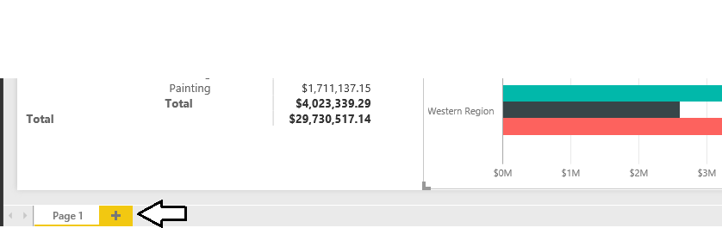

1. Double click on the page name of **Page 1** to enter edit mode and then update the page name to **Sales by Product Category**.



1. Save the report by dropping down the reports **File** menu and selecting the **Save As** menu command.

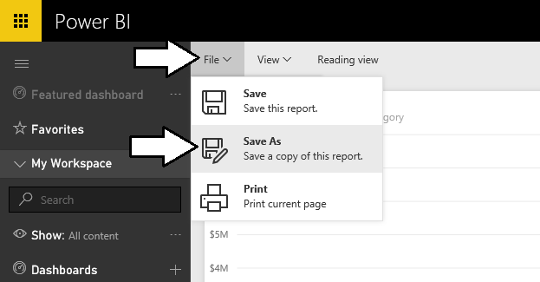

1. When prompted, enter a report name of **Product Sales** and click the **Save** button.

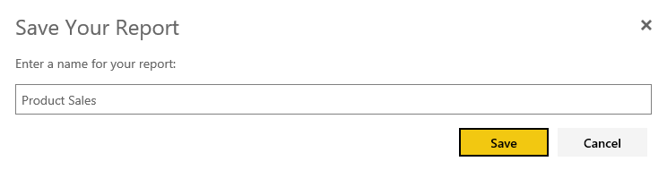

1. After saving the **Product Sales** report, you should be able to see a link for it in the **Reports** section of the left-hand navigation.
2. Now, add a second page to the **Product Sales** report. Accomplish this by clicking the button with the plus (+) sign to the right of the page name. The Power BI service will respond by creating a second page named **Page 1**.



1. Change the name of the second page from **Page 1** to **Sales by Product**.



1. On the new **Sales by Product** page, add a new slicer visual
   1. Add a new table visual by selecting the checkbox beside the **Product** field from the **Fields** list. Resize the height of the table visual to display all products at once without the need for a scrollbar.

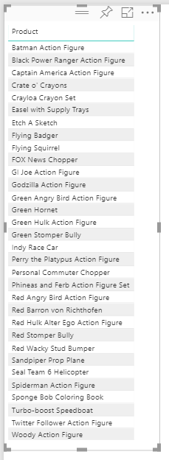

* 1. Change the type of visualization from a table to a slicer by clicking the **Slicer** button in the **Visualizations** list.

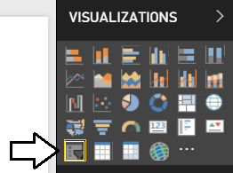

* 1. Now that the visualization has been changed to a slicer, you should see that each product has an associated checkbox.

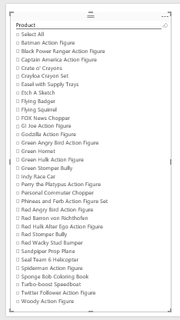

Keep in mind that this slicer visual adds the ability for the current user to intact with this report by selecting one or more products using these checkboxes. When a user changes the selection of products, the Power BI service will automatically refresh the other visualizations on the page by filtering the results using the selected product or products. Learning how to make reports interactive is a key to creating effective BI solutions with Power BI.

1. Add a second visualization to **Sales by Product** page.
   1. Click whitespace in the report to ensure the first visualization is not selected.
   2. Create a new visualization by selecting the checkbox for the **Sales Revenue** field and then selecting the checkbox for the **Fiscal Year** field.
   3. Use the mouse to reposition the new visual so it takes up the top right corner of the page.
   4. The new visual as a bar chart should now match the following screenshot.

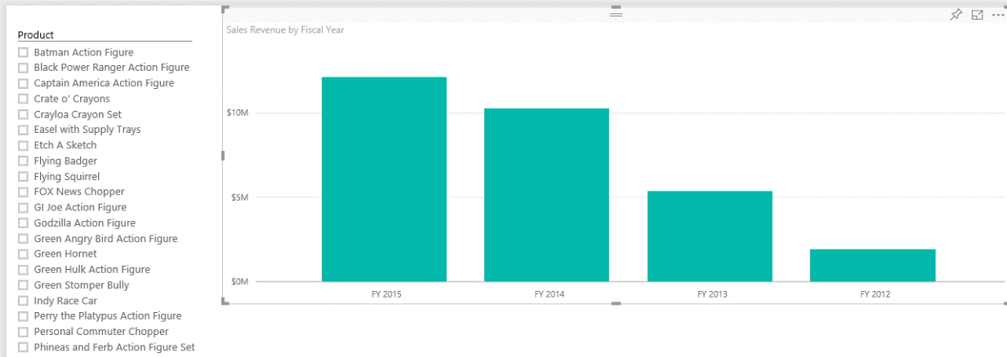

Note that the bar chart has been created with the fiscal years decreasing as it moves from left to right. In the next step you will reverse the order of the columns in this bar chart so that columns for earlier years are sorted to the right and that later years are sorted left.

* 1. Click the flyout menu at the top-right corner of the bar chart visual and select **Sort By Fiscal Year** menu command.

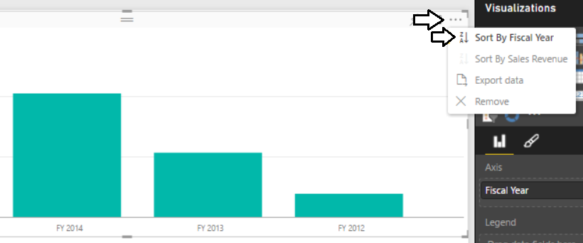

* 1. The bar chart should now display its bars with fiscal year increasing as you move to the right.

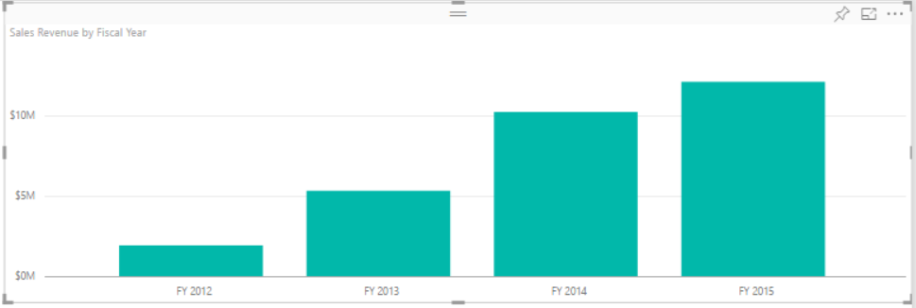

* 1. With the bar chart selected, look inside the **Format** properties pane and locate the **Data colors** section. Inside the **Data colors** section, you should see that the **Show all** property is set to **Off**.

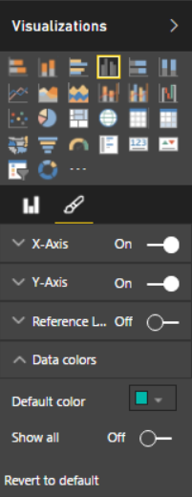

* 1. Change the **Show all** property to **On**.
  2. Assign a different color to each of the 4 fiscal years.

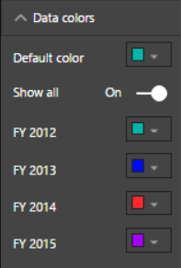

* 1. Your bar chart should now display bars that have a different color for each year.

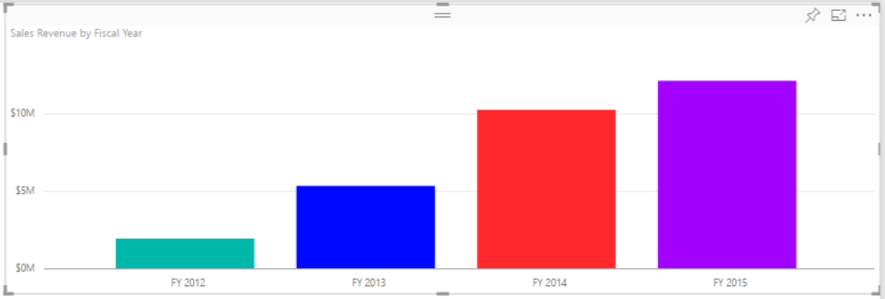

1. Add a third visual to the page.
   1. Click whitespace in the report to ensure the neither of the two visualizations are currently selected.
   2. Create a third visualization by selecting the checkbox for the **Sales Revenue** field and then selecting the checkbox for the **Sales Region** field.
   3. Use the mouse to reposition the new visual so it takes up the bottom right corner of the page.
   4. The new visual should now match the following screenshot.

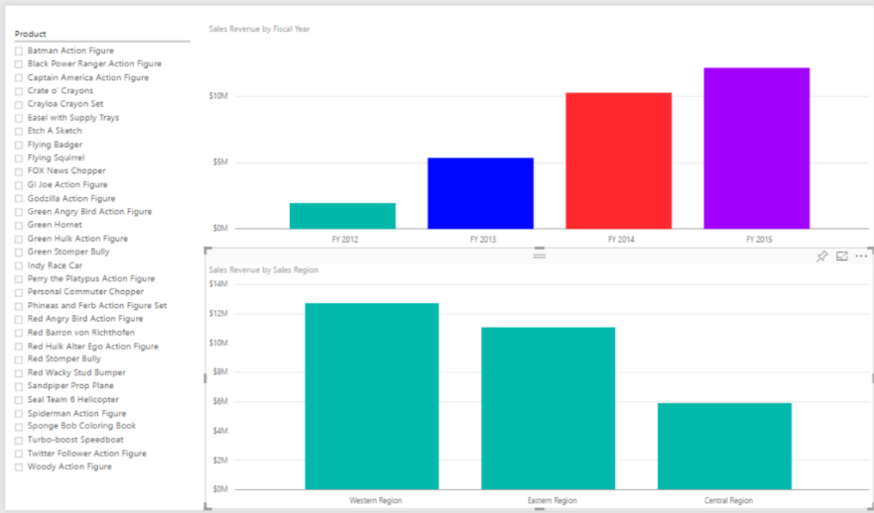

* 1. Modify the **Data colors** section in the **Format** properties pane to give each column its own unique color.

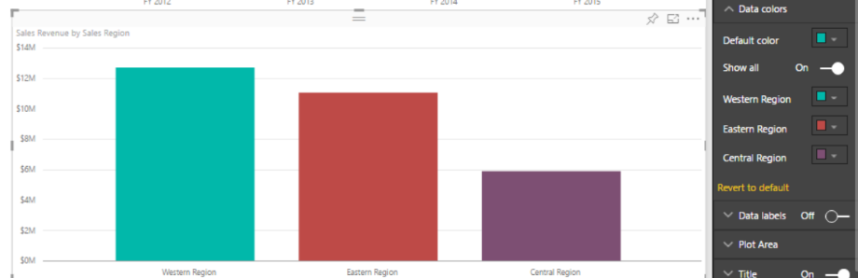

* 1. Save you work by executing the **Save** command from the **File** menu.

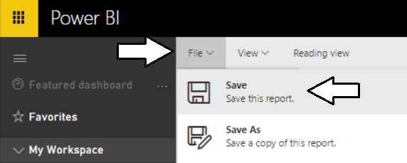

1. Test out the interactive effect of selecting products in the slicer.
   1. Select one product at a time.

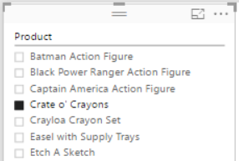

* 1. Observing how the two other visualizations on the page automatically refresh to show sales data for one product at a time.

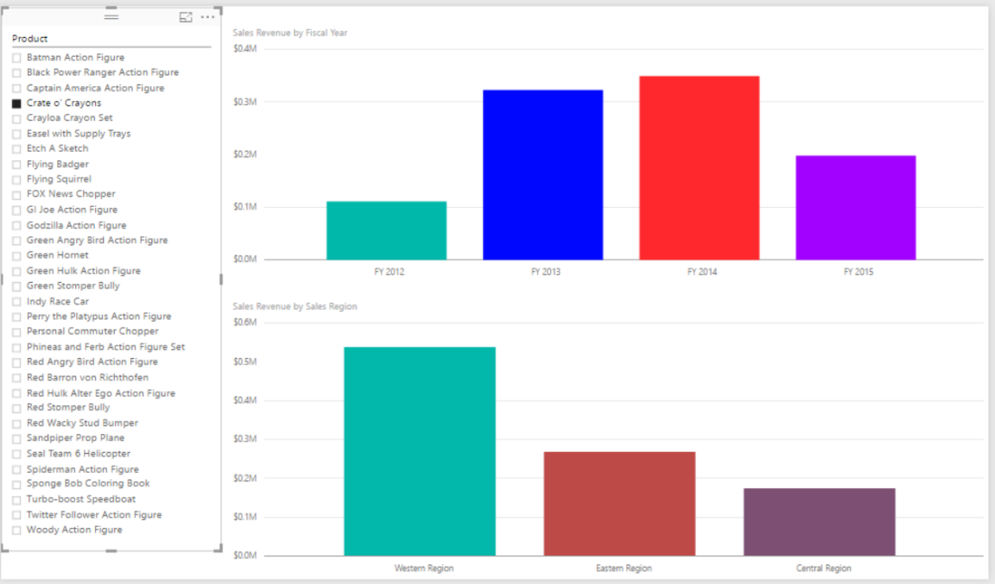

* 1. Play the role of a business analyst and determine which products have the most positive increases in sales revenue from year to year. Also, find the products with downward trending sales. If you examine the sales data for the **Crate o’ Cranyons**, you can sales revenue for this is trending in the wrong direction over the last four years. What other products are shows decreasing sales in this set of 32 products?

Now that you have created a report with multiple pages, it is time to move on to the next exercise where you will create a new dashboard and then you will test sharing this dashboard with another user in your Office 365 trial tenant.

### Exercise 5: Create a Power BI Dashboard

Now that you have created a dataset and a report, you will now create a simple dashboard.

1. Navigate to the **Sales by Product Category** page of the **Product Sales** report.
2. Inspect the Clustered bar chart with product categories. Locate and click the button with the thumbtack icon which is used to pin a report visualization to a dashboard.

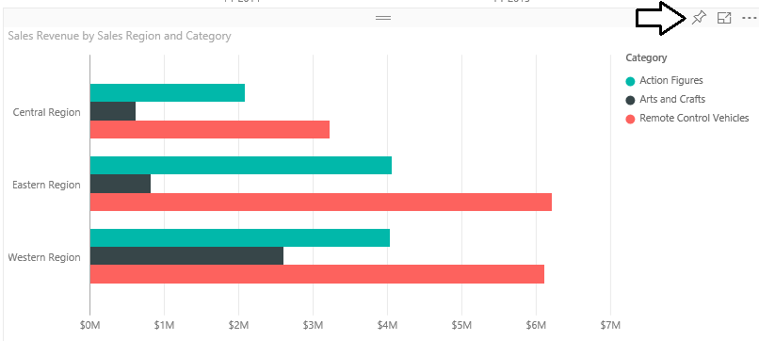

1. When you click the button with the thumbtack icon, you will be prompted with the dialog which asks you where to pin the visualization. Select the option to pin the visualization to a **New Dashboard** and give the new dashboard a name of **Product Sales**. When the **Pin to Dashboard** form is filled out like the one shown in the following screenshot, click the **Pin** button.

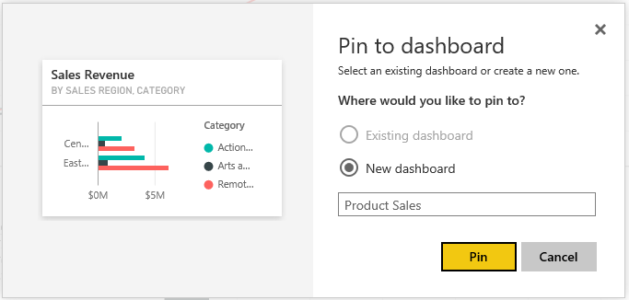

1. At this point, the new **Product Sales** dashboard should be created and a link to it should appear in the left navigation menu.

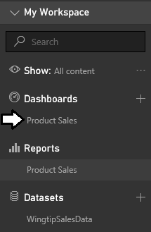

1. Navigate to the **Sales by Product** page of **Product Sales** report and follow the same steps to pin the bar chart visualization showing sales revenue by fiscal year to the **Product Sales** dashboard.

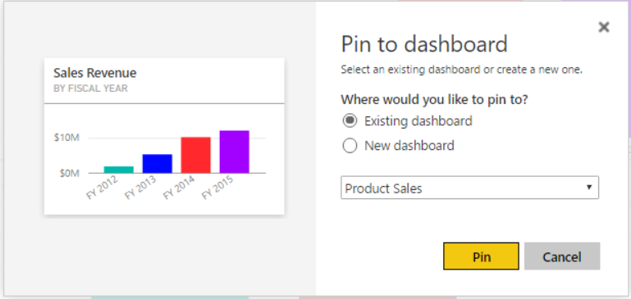

1. Remain on the **Sales by Product** page of **Product Sales** report and follow the same steps to pin the bar chart visualization showing sales revenue by sales region to the **Product Sales** dashboard.

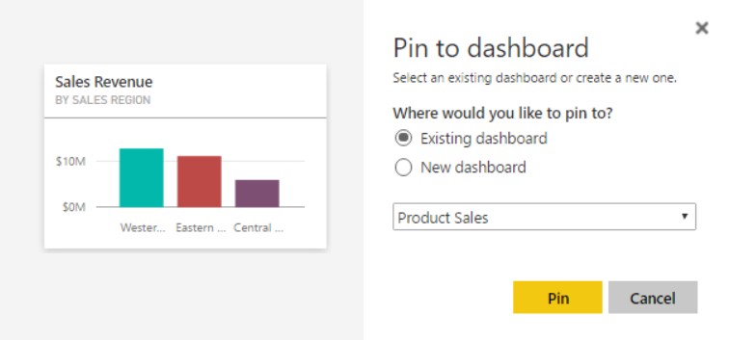

1. Click on the **Product Sales** link in the **Dashboards** section of the left navigation menu to display the **Product Sales** dashboard. You should be able to verify that you see three tiles that have been created from the three report visualization that you pinned to this dashboard.

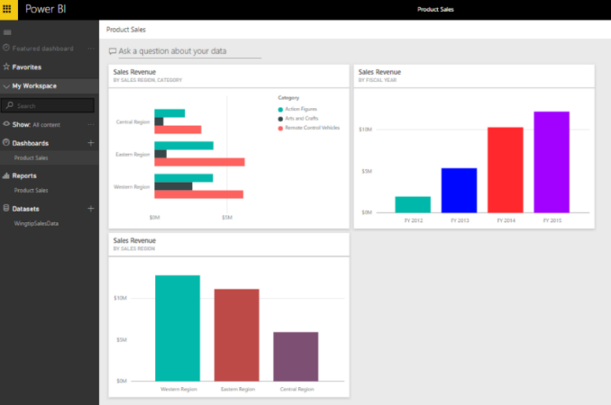

1. Note that you can move or resize the tiles inside the dashboard. This is due to the fact that you are the dashboard author and you are in dashboard edit mode. Use your mouse to rearrange the tiles in the dashboard to match the screenshot below.

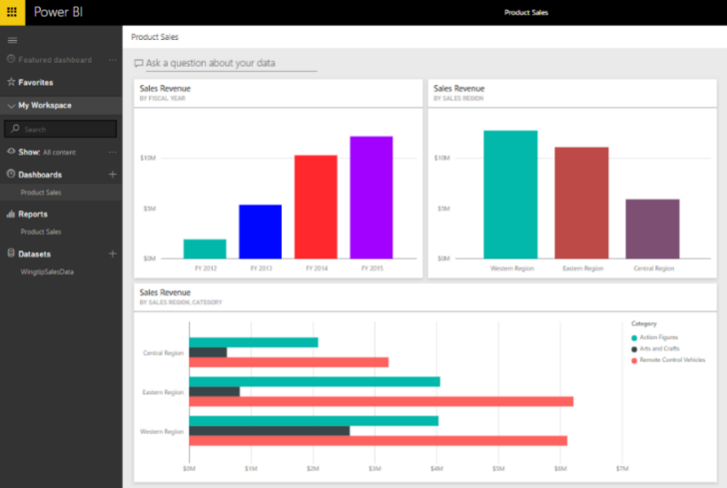

1. Experiment by clicking on the tiles in the dashboard. You will find that clicking a tile will navigate the user to the report and page that contains the visualization which was pinned to the dashboard.

Now you have created a dataset, a report and a dashboard which are the main three building blocks when building data analytics and reporting solutions with Power BI. Next, you will experiment with the Power BI Quick Insights feature to see if it has anything interesting to say about the dataset you have just imported.

### Exercise 6: Get Quick Insights on a Power BI Dataset

In this exercise, you will run a Power BI command to generate quick insights for the WingtipSalesData dataset.

1. Get Quick Insights on the dataset named **WingtipSales**.
   1. Drop down the fly out menu for the **WingtipSaleData** and click the **VIEW INSIGHTS** menu command.

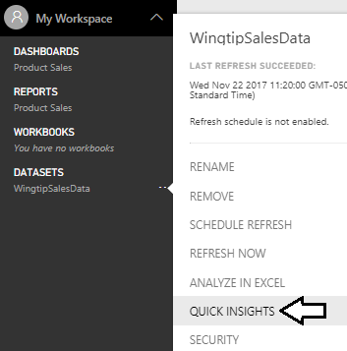

* 1. Wait while the gathering insights process runs. It should not take more than

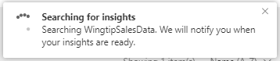

* 1. When you see the **Insights are ready** notification, click the **View insights** button.

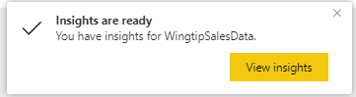

* 1. The Power BI service should generate a page with the title **Quick Insights for WingtipSalesData**. Take a few minutes to review all the quick insights that have been generated.

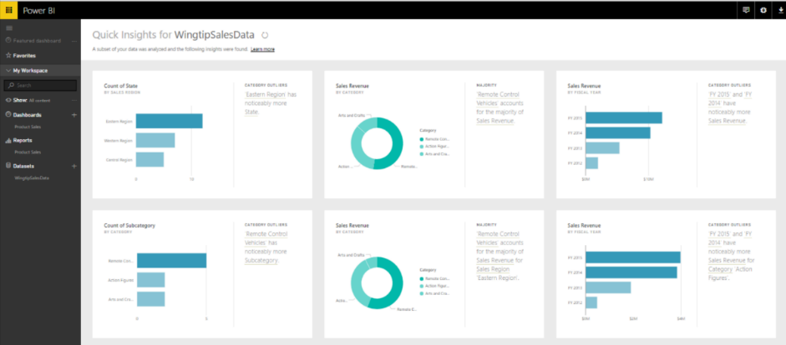

In the final exercise you will open a project in Power BI Desktop and publish it to the Power BI service.

### Exercise 7: Getting Started with Power BI Desktop

In this exercise, you will first download and install Power BI Desktop if you have not already done so. Note that if Power BI desktop is already installed on your student workstation, you can skip ahead in this exercise to step 12.

1. Using the browser, navigate to the landing page of the Power BI service at <https://app.powerbi.com>.
2. On the top right of the Power BI service window, drop down the **Downloads** menu and click the **Power BI Desktop** menu command to begin the download of the installation file.

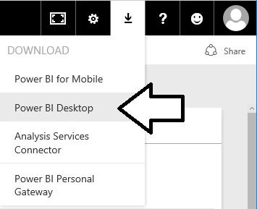

1. Wait for the MSI file to download.



1. Once the file has downloaded, click the **Run** button to begin the installation of Power BI Desktop.



1. When you see the Welcome screen, click **Next** to continue with the installation.

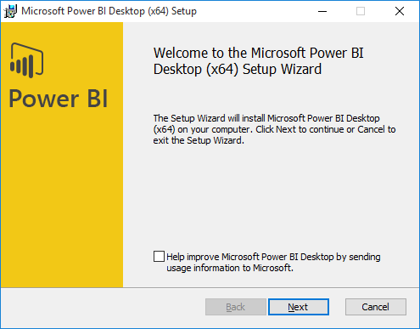

1. Click the checkbox to accept the license agreement and click **Next**.

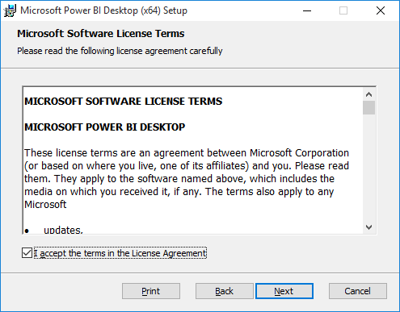

1. Accept the default location for the installation and click **Next**.

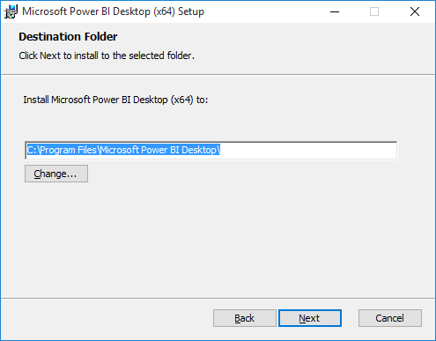

1. On the next screen, click **Install**.

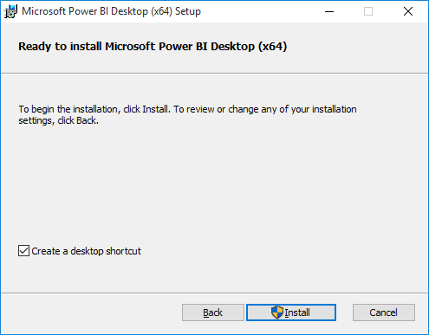

1. When you see the **Completed the Microsoft Power BI Desktop Setup Wizard** screen, click **Finish** to launch Power BI Desktop.

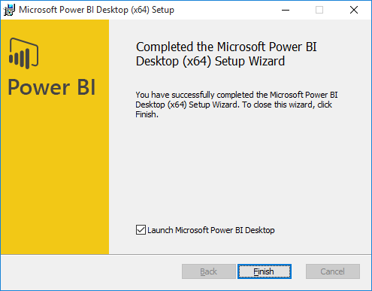

1. When Power BI Desktop launches for the first time, it displays a Welcome screen as shown in the following desktop. Click the (**X**) button in the upper right corner to close this window.

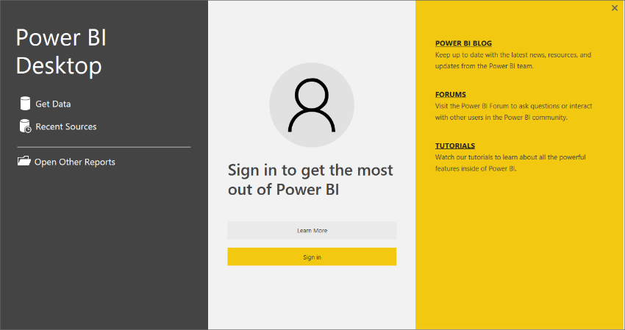

1. At this point, you should have Power BI Desktop running with a new, unsaved project as shown in the following screenshot.

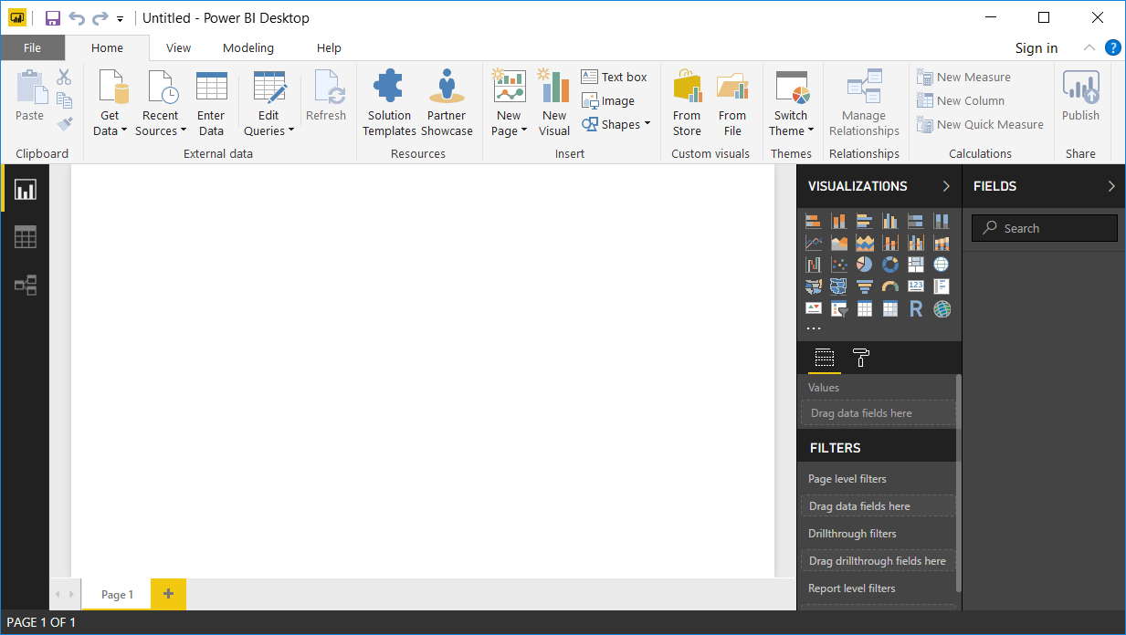

You can start this exercise here if Power BI Desktop was already installed.

1. Open the Power BI Desktop project file named **Lab01.pbix**.
   1. Select he **File > Open** command from within Power BI Desktop.

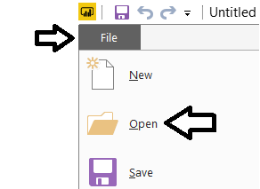

* 1. Locate the PBIX file located at the following path.

C:\Student\Projects\Wingtip Sales Analysis.pbix

* 1. Open **Lab01.pbix** to load this project into Power BI Desktop.

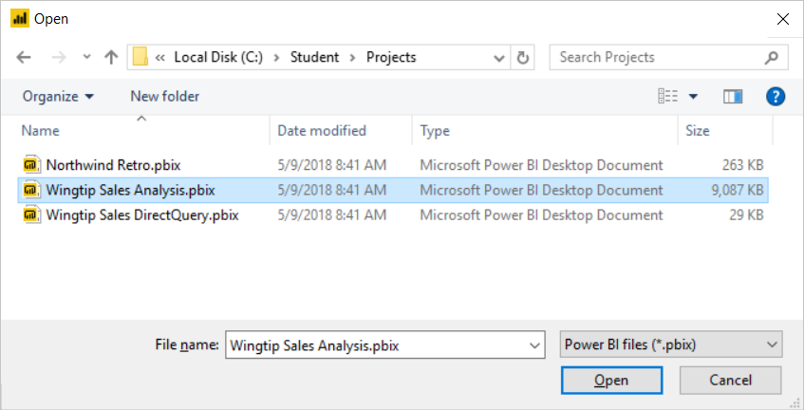

The project should now be open in Power BI desktop.

1. Inspect the contents of the Power BI Desktop project named **Lab01.pbix**.
   1. Inspect the report that has been created inside this project. You should see if provides four pages.

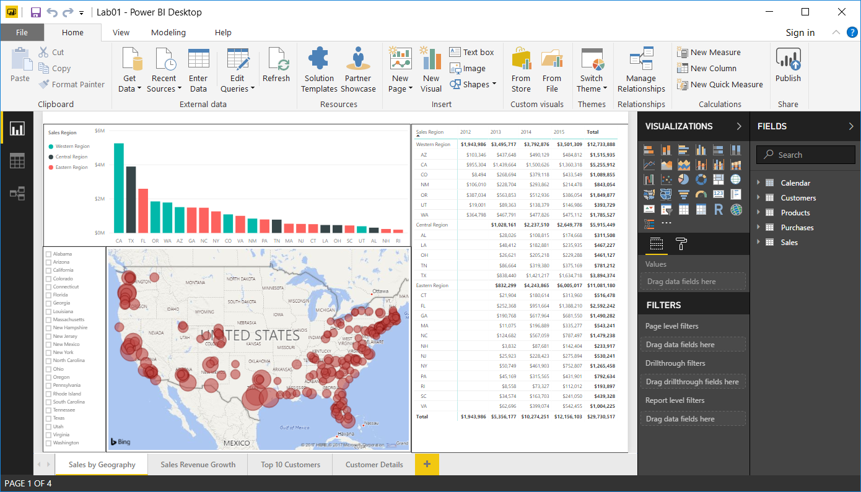

* 1. Using the navigation tabs at the bottom of the report, move from page to page to inspect each page in the report.

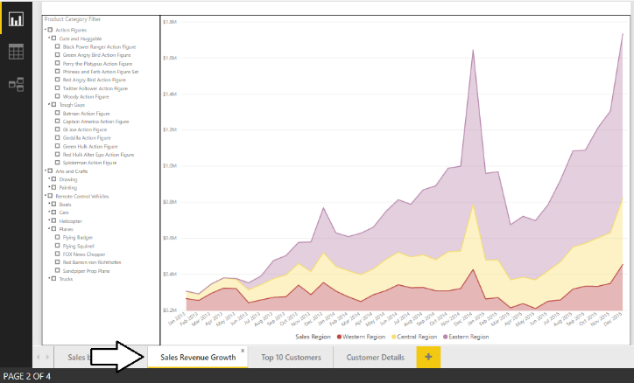

* 1. Click on the Relationship view button in the left navigation to see the tables included in data model and their relationships.

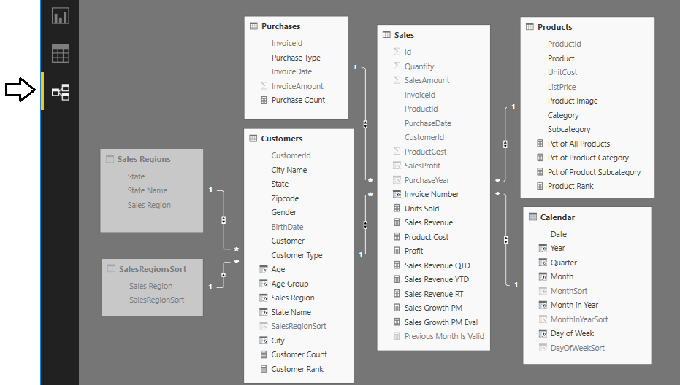

* 1. Click on the Data view button in the left navigation to see a tabular view of the data inside the project’s data model. Note that you can select a table in the FIELDS list on the right to see the data in that table.

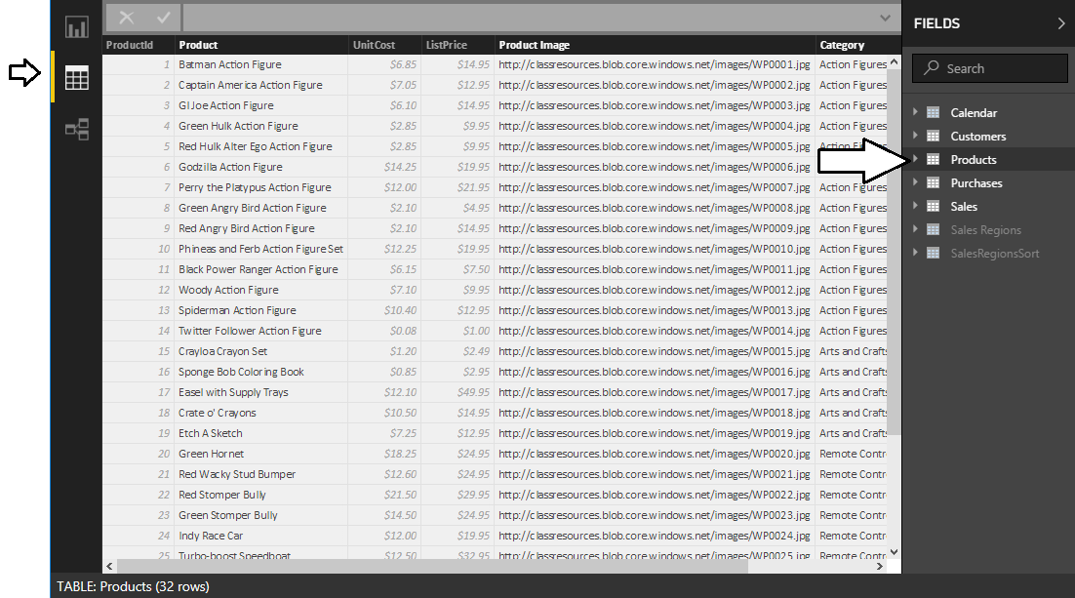

You do not need to make any changes to the Power BI Desktop project named **Lab01.pbix**. The purpose of this lab is for you to open an existing project that has already been completed and then to publish it to your personal workspace.

1. Publish the **Lab01.pbix** project to the Power BI Service.
   1. Navigate to the **Home** tab in the ribbon and click the **Publish** button on the far right-hand side.

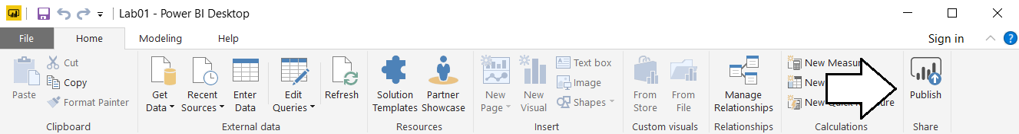

* 1. When promoted with the **Sign in to Power BI** dialog, click the **Sign In** button

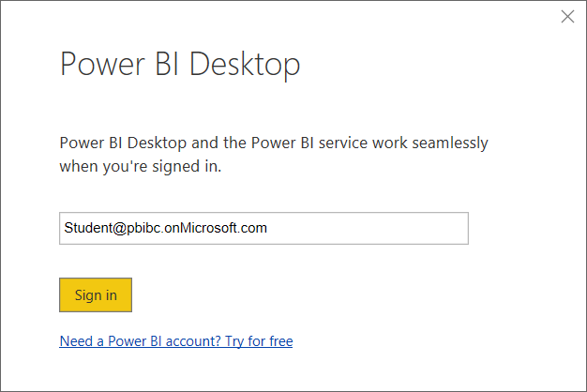

* 1. When prompted for your password, sign into the Power BI service.
  2. When Power BI Desktop prompts you with the **Publish to Power BI** dialog, select **My workspace** and then click **Select**.

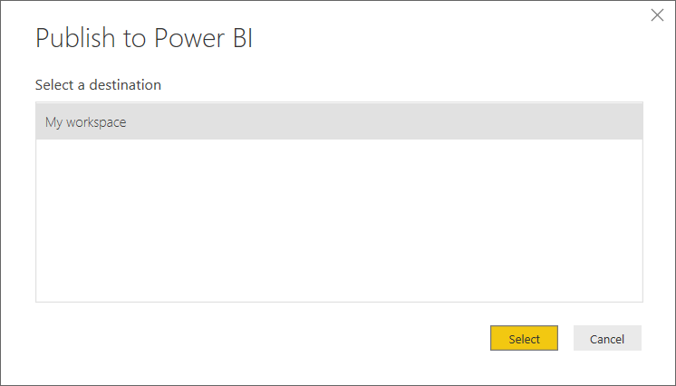

* 1. Power BI Desktop will display the **Publishing to Power BI** dialog as the publishing process begins.

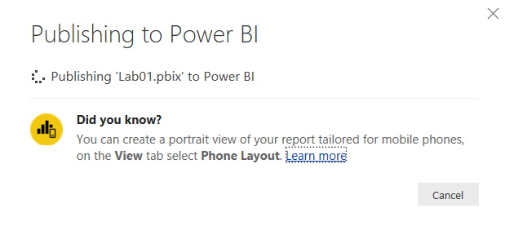

* 1. Once the publishing process has completed, the **Publishing to Power BI** dialog will display a success message and provide you with a link to **Open Lab01.pbix in Power BI**. Click on that link to navigate to the Power BI service using the browser.

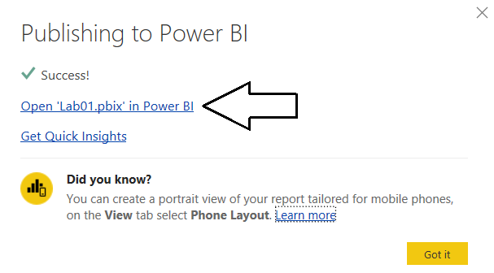

* 1. You should now be able to see the **Sales by Month** page of the report you just created.

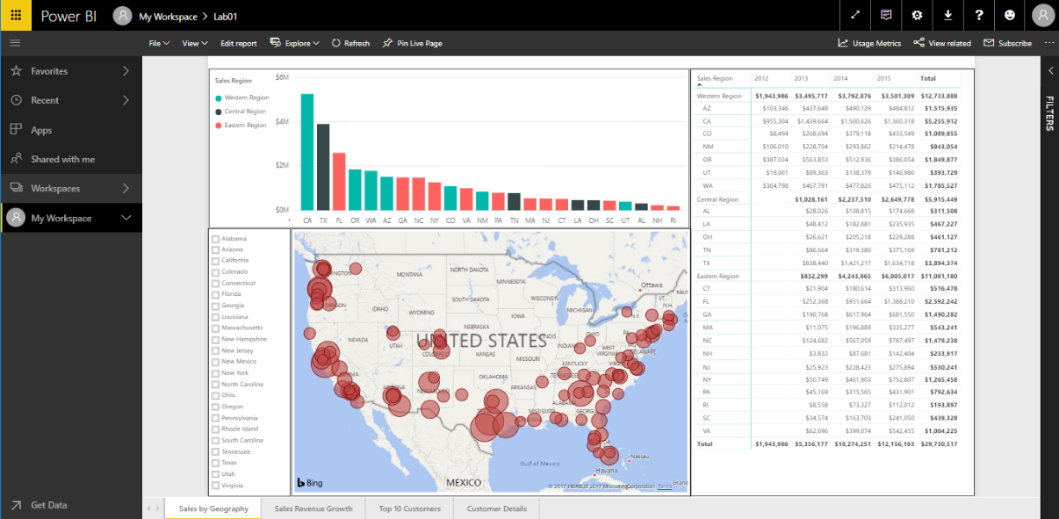

* 1. Click on the **Sales by State** link at the bottom of the screen to see the second page of the report.

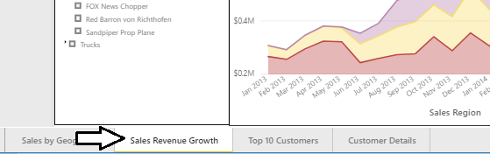

You have now successfully published a PBIX project using Power BI Desktop. But what happens when you want to make a change to a report after it has been published? It’s very easy because you can make changes to your Power BI Desktop project and republish it on top a previous version of the same project that has already been published.

1. Change the type of the visual that displays sales revenue by month and purchase type.
   1. Return back to Power BI Desktop and make sure you are in report view for the project named **Lab01.pbix**.
   2. Return to the **Sales by Geography** page.
   3. Select the **Map** visual.

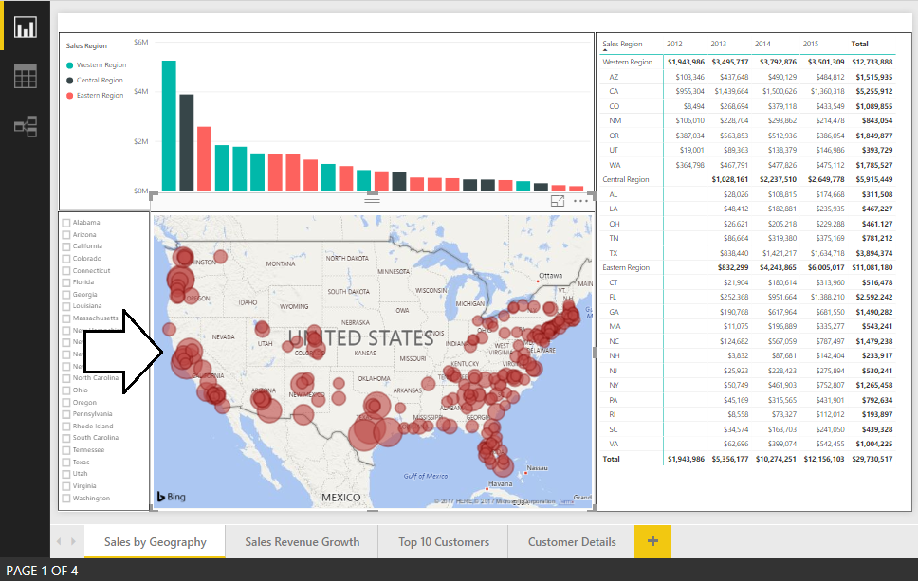

* 1. Update the **Default color** property in the **Data colors** section in the **Format pane** to change the color of the bubbles from red to a different color such as yellow or purple.

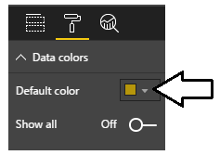

* 1. Verify that the bubbles in the Map visual are now a different color than red.

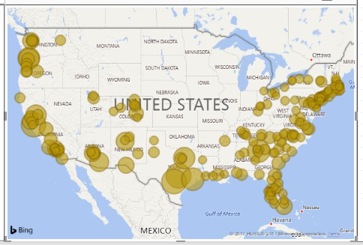

* 1. Save your changes to **Lab01.pbix**.

1. Republish the project to the Power BI service.
   1. Click the **Publish** button on the far right-hand side of the **Home** tab in the ribbon.
   2. When Power BI Desktop prompts you with the **Publish to Power BI** dialog, select **My workspace** and then click **Select**.
   3. When prompted with the **Replacing dataset** dialog, click Replace to begin the publishing process.

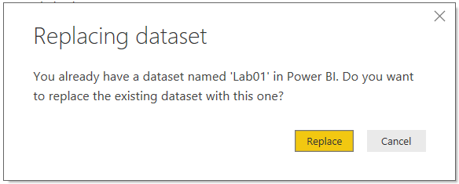

* 1. Once the publishing process has completed, inspect the published report in the Power BI service using the browser. Verify that the bubble color within the Map visual has been updated.

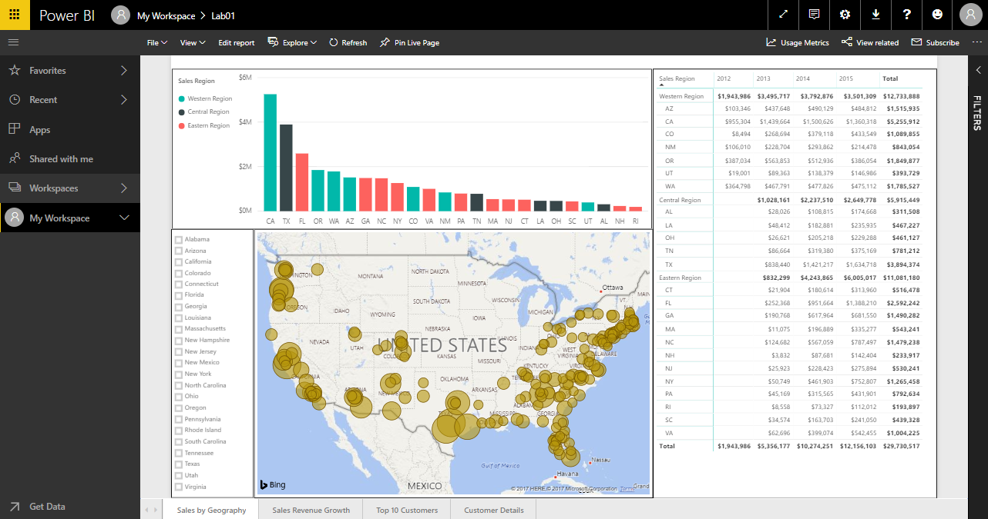

Congratulations, you have now finished this lab. If you finish early before other student and you still have extra time, experiment by clicking the **Edit report** button in the browser and seeing how you can continue to modify the pages of the report after the report has been published to the Power BI service. Note that any changes you make to the report through the browser will be overwritten if you republish the report with Power BI Desktop.